Query the **NAME** field for all American cities in the **CITY** table with populations larger than 120000. The CountryCode for America is USA.

The **CITY** table is described as follows:  
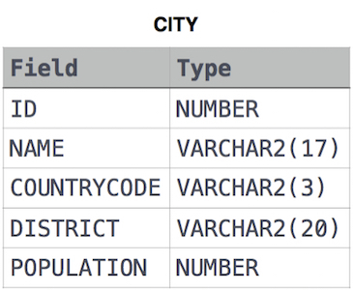

**Ans:**

select NAME from CITY where POPULATION >120000 and COUNTRYCODE = 'USA';